[local MRC unit]

What does the MRC do?
What is the Medical Reserve Corps?
The Medical Reserve Corps (MRC)
is a national network of trained medical and non-medical volunteers
who support public health initiatives and strengthen emergency response capabilities.
In Illinois, MRC units operate locally to meet the specific health and safety needs of their
communities.

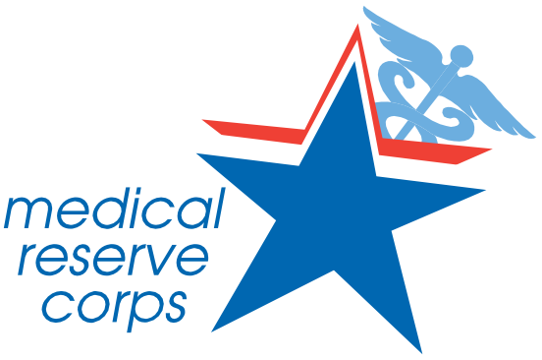
MRC volunteers assist in a wide range of public health and emergency preparedness activities, including:
 Providing support during disease outbreaks, natural disasters, and other emergencies
 Staffing vaccination and testing clinics
Offering mental and behavioral health services
Supporting medical shelters or surge healthcare needs
Participating in public education and preparedness events

How do MRC units benefit the community?
MRC units improve community resilience by:
Expanding public health capacity during crises
Offering surge staffing when healthcare systems are strained Supporting prevention-focused outreach and health education Assisting vulnerable populations in emergencies

Who volunteers with the MRC?
Volunteers include medical healthcare professionals such as physicians, nurses, pharmacists, EMTs, mental health professionals, dentists, veterinarians, and public health specialists. Many are currently employed or retired from healthcare roles, and others are students or non-clinical professionals supporting with logistics, administration, and communication.

Why should I volunteer?
Volunteering with the MRC allows you to:
Use your professional skills in meaningful ways beyond your workplace Support your community in times of need
Stay engaged with emergency preparedness efforts Gain access to unique training opportunities
Build professional networks and enhance your resume Give back—on your schedule

How can I volunteer with the MRC?
Start by visiting mrcillinois.org to find and connect with your local unit. From there, you’ll complete a registration process, including any required documentation or background checks. Each unit provides orientation, training, and guidance to ensure you’re ready to serve.

Am I eligible to volunteer?
Yes, if you:
Are 18 years of age or older
Meet your local MRC unit’s requirements (which may include licensure verification or background checks)
Complete unit-specific training

Most units are actively seeking medical professionals to serve in both clinical and non-clinical roles, based on local needs.

Have more questions? Contact us at [Email Address] – we’d love to hear from you!

