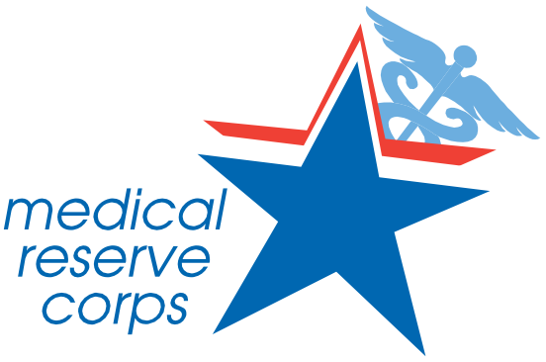

Just the Facts...the Medical Reserve Corps Program in Illinois

The Medical Reserve Corps Program in Illinois is a
statewide network of dedicated volunteers—both medical and
non-medical— committed to protecting public health, enhancing emergency
response, and fostering community resilience.
Whether responding to disasters, promoting wellness, or assisting in local health initiatives, MRC
volunteers play a crucial role in keeping Illinois safe and prepared.

Why Volunteer?
 Help Your Community – Support local disaster response efforts, assist at health events, and promote public safety.
Gain Real-World Experience – Build leadership, communication, and crisis response skills that enhance your career.
Flexible Opportunities – Whether you have a few hours or want to commit long-term, there’s a role for you.
Make a National Impact – Join a network of 300,000+ volunteers helping communities across the U.S.

MRC’s Nationwide Impact on COVID-19
Contributed 2.4 million hours vaccinating Assisted with 65,000+ testing events
Managed 56,000+ call center hours
Provided 30,000+ hours of contact tracing

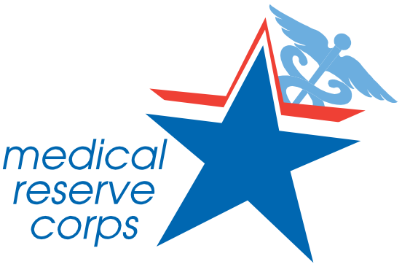
In Illinois (2024 alone):
5,191 volunteers participated
1,331 activities reported
8,401 hours contributed
134,981 people served
$317,081+ value of volunteer contributions

Volunteer Roles for All Backgrounds
 Community Outreach & Education – Help with public health awareness and emergency preparedness.
Medical & First Aid Support – Assist at health clinics, vaccination sites, and emergency shelters.
Administrative & Logistics Support – Organize events, manage data, and coordinate volunteer efforts.
Behavioral Health Assistance – Provide Psychological First Aid and crisis support.
Emergency Response Training – Learn skills like search and rescue, active bystander response, and animal rescue.

Who Can Join?
Medical professionals (Doctors, Nurses, EMTs, etc.) – 60% of MRC members
Non-medical volunteers – 34% of MRC members
Behavioral health specialists – 6% of MRC members
Students & young professionals – Gain experience while giving back!

Find a Local Unit & Sign Up:


Be the Difference. Join Today!
mrcillinois@gmail.com
mrcillinois.org
Your skills, your time, your impact. Volunteer with MRCIL!

