MRCIL

Healthcare Digital Toolkit – Social Posts

Post Content | Photo Used for Post
Your skills can save lives beyond the hospital or clinic. By joining [local MRC unit], you can:  ✅ Provide vital support during emergencies  ✅ Assist in public health initiatives  ✅ Make a meaningful impact—on your schedule!  Whether you're a doctor, nurse, EMT, pharmacist, or other healthcare worker, your expertise matters. Volunteer today and be a part of something bigger!  Ready to make a difference? Join us today! [Insert Registration Link] | 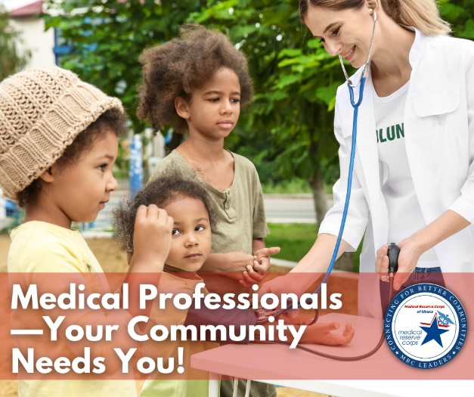
🏥 Calling All Medical Professionals! 🩺  Your expertise can make a life-saving difference in your community. By volunteering with [local MRC unit] you’ll have the opportunity to:  ✅ Support public health initiatives  ✅ Respond to emergencies  ✅ Share your skills to strengthen your community  Whether you’re a doctor, nurse, EMT, pharmacist, or other healthcare professional, your time—no matter how much you can give—helps create healthier, safer communities.  Ready to make a difference? Join today! [Insert Registration Link] | 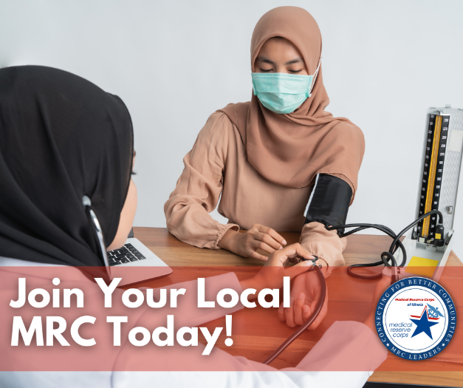
Your skills and expertise can make a life-changing difference in your community. By volunteering with [local MRC unit], you’ll have the opportunity to:  ✔️ Support public health initiatives  ✔️ Assist during emergencies and disasters  ✔️ Educate and empower your neighbors to live healthier lives  Whether you have a little time to give or a lot, your contributions as a medical professional are invaluable. Join a dedicated team of volunteers making Illinois safer, healthier, and stronger.  Ready to be part of something bigger? ➡️ Sign up today! [Insert Registration Link] | 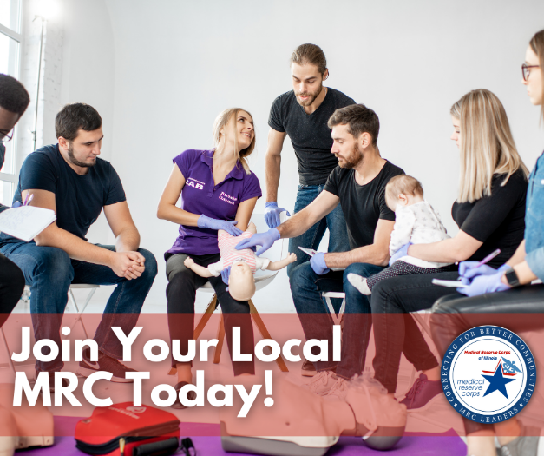
When disaster strikes, volunteers play a vital role—and that includes the Medical Reserve Corps! While not first responders, [local MRC unit] volunteers act as the missing puzzle piece that helps everything come together. From supporting shelters to assisting with logistics and public health needs, MRC members provide essential services that make a big impact during challenging times.  Want to be part of the team that helps communities recover and rebuild? Join us! [Insert Registration Link] | 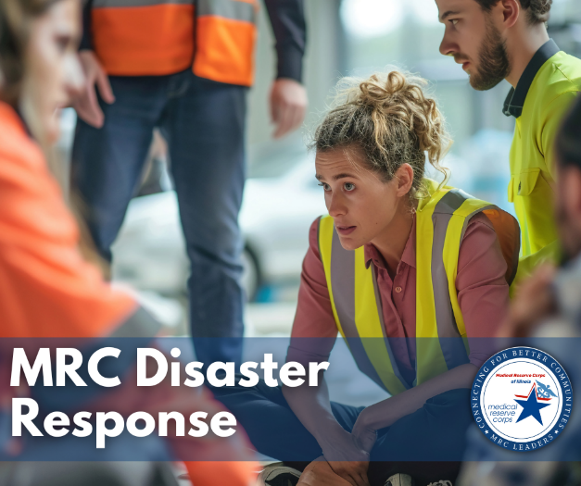
The [local MRC unit] needs YOU to help strengthen communities in times of need. Whether it’s supporting emergency preparedness, assisting with disaster response, or participating in health initiatives, your expertise can make a real difference.  Join us today and help ensure your community is ready when it matters most!  Learn how you can become an MRC volunteer at [Insert Registration Link] | 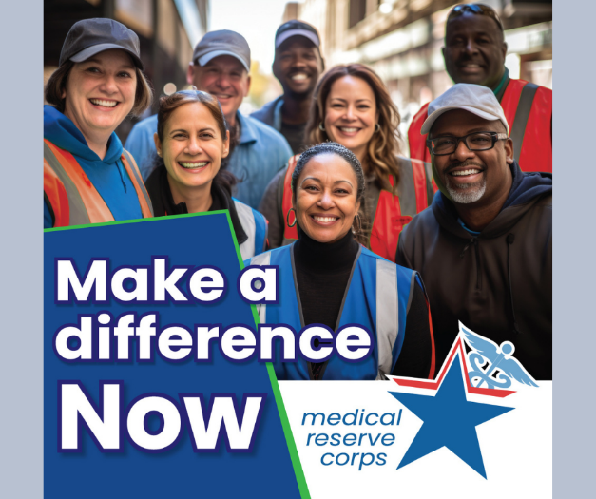
🚨 Looking to make a difference beyond the walls of your clinic or hospital?  Join the [Local MRC unit] and put your healthcare skills to work supporting public health, emergency preparedness, and your community—on your schedule.  👉 Learn more: mrcillinois.org or unit specific URL | 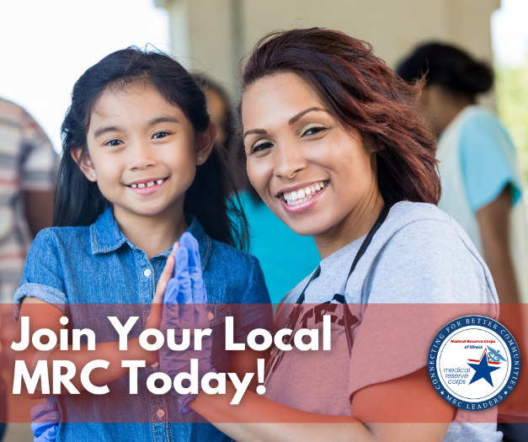
💡 You don’t have to be an emergency room doc to help in an emergency.  From logistics and operations to behavioral health and clinical care, the MRC welcomes all licensed healthcare professionals.  ✅ Physicians, nurses, pharmacists, EMTs, and more—your expertise matters.  Step in where your community needs you: mrcillinois.org/ad-campaign | 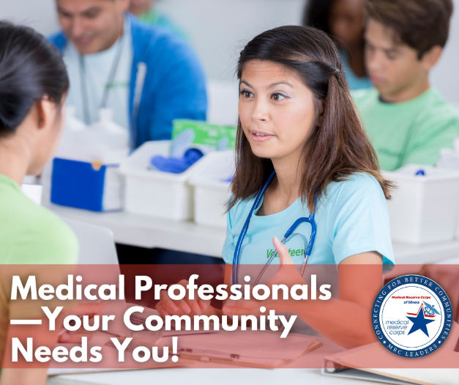
⏰ Flexible. Purposeful. Impactful.  Whether you can offer a few hours a month or immediate support during a crisis, volunteers with the MRC to:  ✅ Use your clinical skills in a public health response  ✅ Stay connected to community health needs  ✅ Make a meaningful impact—on your time schedule  Sign up: mrcillinois.org/ad-campaign or unit specific URL | 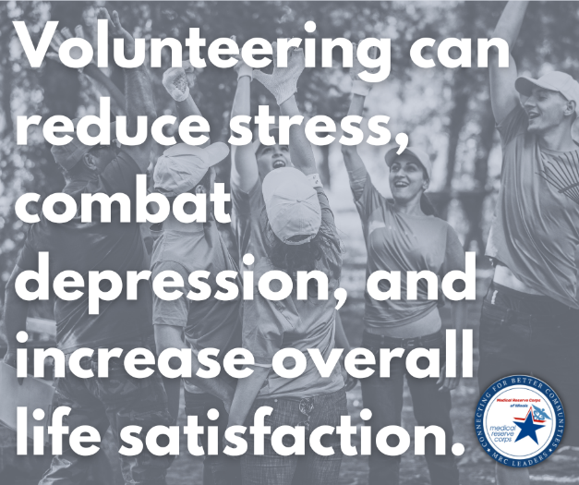
When emergencies strike, communities rely on more than hospitals—they rely on people like you.  Whether it's assisting at vaccine clinics or supporting disaster response, MRC volunteers are a critical part of the healthcare safety net.  🌟 Ready to serve? mrcillinois.org/ad-campaign or unit specific URL | 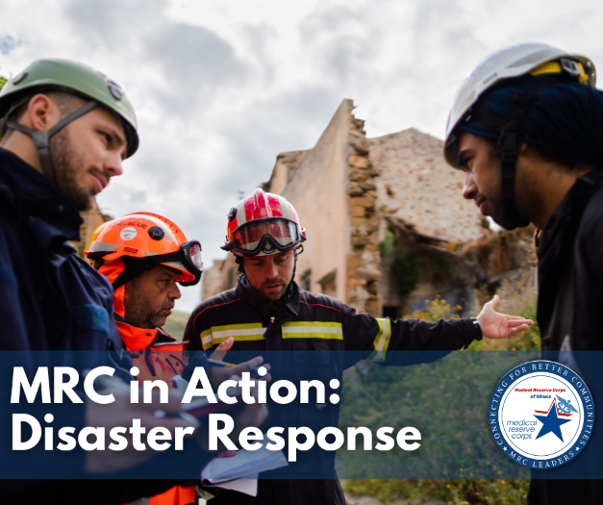
MRC volunteers don’t just show up for disasters—we’re active all year long.  From:  🩺 Health screenings and education events  💉 Vaccination clinics  🧠 Mental health outreach  📦 Community prep initiatives  Your skills can make a year-round impact: https://volunteerwithmrc.org or unit specific URL | 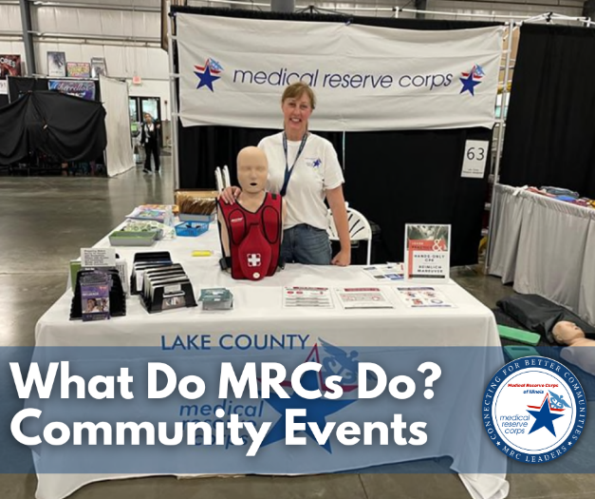
Short on time? No problem.  Whether you help at a one-day event or stay engaged year-round, the MRC offers flexible, meaningful volunteer opportunities for busy healthcare workers (including vets!).  📢 Serve where you're needed: https://volunteerwithmrc.org or unit specific URL | 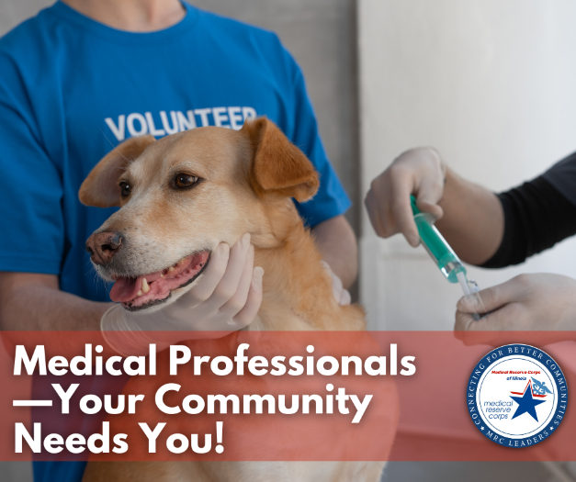
Got questions about volunteering with the MRC? We've got answers.  Explore our FAQ to learn more about training, scheduling, and how your medical license fits into MRC service.  🔍 mrcillinois.org/mrc-volunteer-resources/#volunteer-faqs | 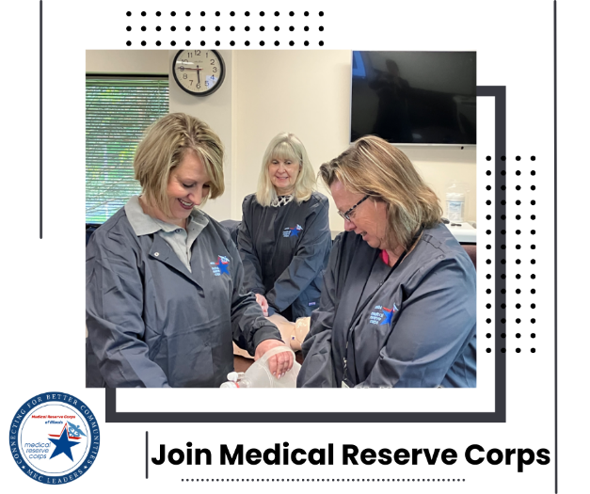
From physicians to behavioral health specialists to support staff, the MRC is powered by healthcare professionals just like you.  💙 Ready to give back using your expertise? Sign up today: mrcillinois.org/ad-campaign or unit specific URL | 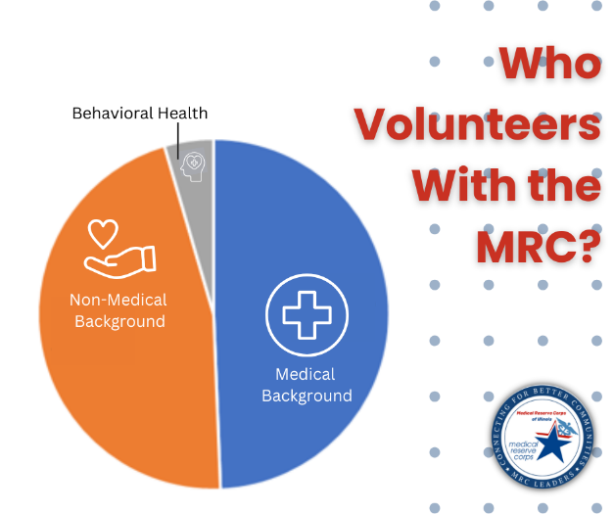
📈 Volunteering boosts your professional profile.  Expand your public health experience, grow your network, and contribute to a cause that matters.  Join [local MRC unit] and make a difference—on your terms. mrcillinois.org or unit specific URL | 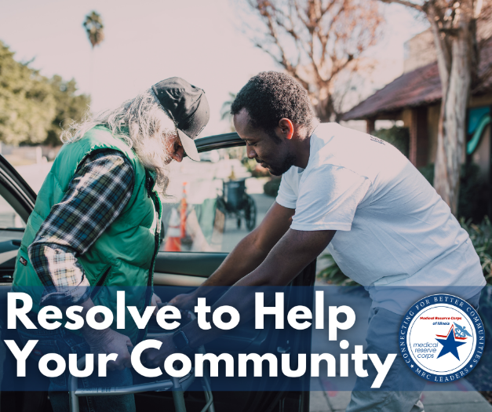
Full-time job? Family responsibilities? You can still make a difference.  The MRC offers flexible volunteer options designed for working professionals.  Help when you can, how you can. 📢 Sign up: https://volunteerwithmrc.org or unit specific URL | 
Volunteering is linked to lower stress and better overall well-being.  Give back to your community—and give yourself the gift of purpose and connection. 💙  Start today: mrcillinois.org/ad-campaign or unit specific URL | 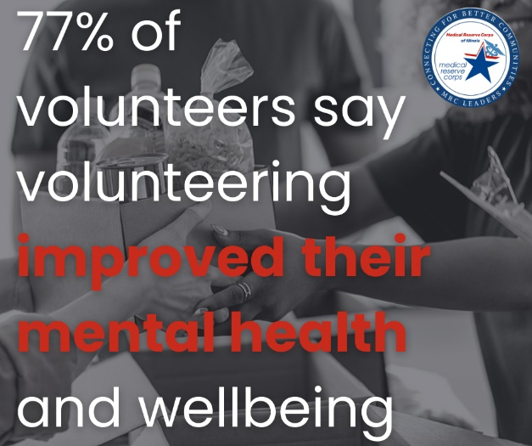
Sharpen your skills and stay mission-ready.  Volunteering with the MRC gives you hands-on experience in emergency preparedness and public health response.  Stay sharp. Stay relevant. Stay ready to lead when it counts.  Join [local MRC unit]: mrcillinois.org or unit specific URL | 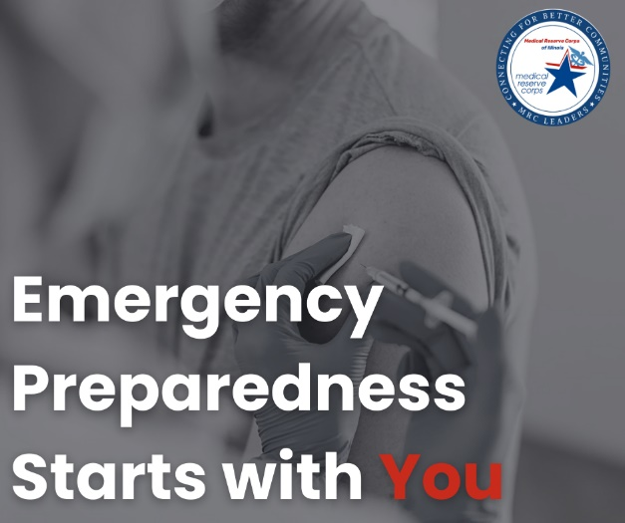
🤝 Connect with a like-minded network of healthcare professionals.  MRC volunteers are a statewide community of passionate people committed to service.  Build meaningful connections, collaborate on community events, and be part of a team that makes a difference.  Find your place at [local MRC unit]. | 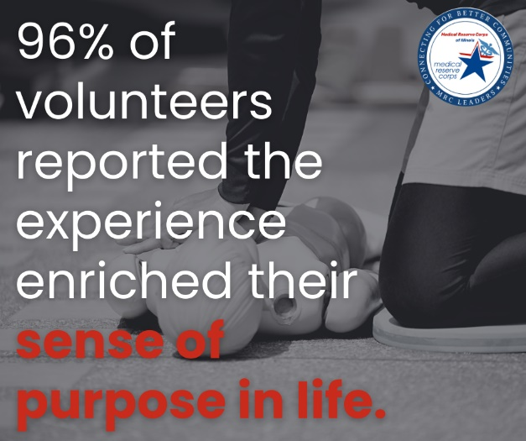
March 2020 changed everything.  Today, we honor the healthcare professionals and volunteers who showed up when it mattered most—and invite you to carry the torch forward.  Whether you’re in a clinic, hospital, or home care setting—your experience can help Illinois prepare for whatever comes next.  Be ready. Be the difference. Join [local MRC unit]. mrcillinois.org or unit specific URL | 