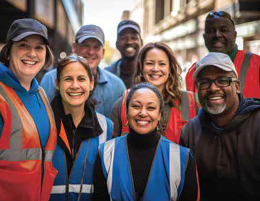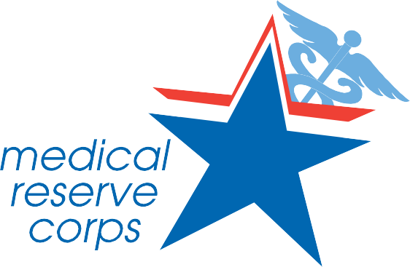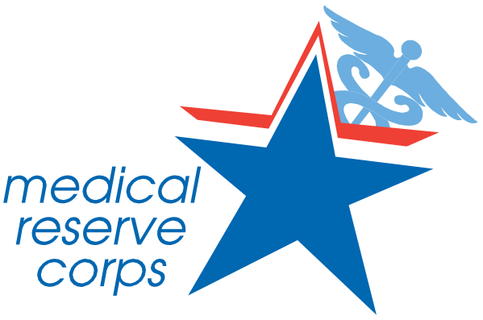InGvetolved

How to Get Involved
- Visit mrcillinois.org to learn more and find your local unit.
- Once you identify the closest unit, contact the local leader.
- Complete the local MRC application.
- Attend orientation and training to prepare for your role as an MRC volunteer.
- Choose your level of involvement.
- Make a difference in your community!

By the Numbers
Over 60 units

in Illinois

Approximately 4,000

volunteers

YOU Matter
One hour of volunteer contribution is an average of $31.80

of value

Join today and make a difference in your community
when it matters most.

@mrcillinois | mrcillinois@gmail.com

mrcillinois.org

Make a

Difference

in Your Community

mrcillinois.org

Who We Are Born from high demand for community volunteers following the 9/11 attacks, the Medical Reserve Corps (MRC) is a
national network of over 300,000 volunteers, organized locally to improve the health and safety of their communities.
The Illinois MRC Program organizes and trains volunteers to support public health initiatives, emergencies, and strengthen healthcare in their communities, often working with local health departments, hospitals, and emergency responders.

What We Do
MRC volunteers support communities in many ways, including:

Community event support (marathons, health fairs, community training, etc.)
Training (CPR, First-Aid, Stop the Bleed, etc.)
As a member of an MRC in Illinois, you'll belong to a vital network ready to respond to emergencies and support public health. You'll be able to:
Make a Difference: Engage family, friends, and neighbors in various training and emergency response efforts.

Enhance Your Skills: Gain valuable training and experience in disaster response, public health, and community outreach.

Serve Your Community: Support local health initiatives, vaccination clinics, health fairs, and education programs aimed at improving public health and safety.
Build Connections: Network with healthcare professionals, first responders, and community leaders while making an impact in your community.

Volunteer Opportunities
How often you volunteer is up to you! Choose from a variety of roles based on your skills, experience, and interests:
Medical Professionals: Lend expertise in emergency medical care, triage, patient assessment, and dispensing. Note, it is your decision if you want to use your medical license.
Non-Medical Volunteers: Support logistics, administration, education, interpretation, crowd management, and other crucial roles during emergencies. Non-medical volunteers are needed in all types of activities!

No matter your background or experience level, there's a place for you in a Medical Reserve Corps Unit in Illinois.
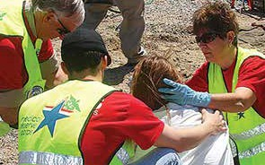

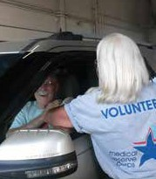
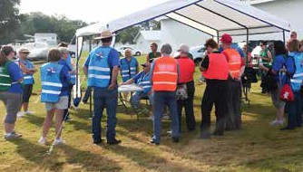

Logistical support (admin, computer work, translation, traffic control, etc.)
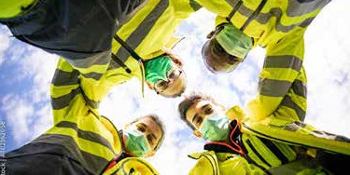

Emergency Response (cooling centers, crisis counseling, search & rescue, responder rehab, evacuation efforts, etc.)
Public health (mass dispensing, vaccinations, health education, etc.)

